CODING ASSESMENT – PYSPARK

[Jobaoushadancse2021@jerusalemengg.ac.in](mailto:Jobaoushadancse2021@jerusalemengg.ac.in)

Job Aoushadan N – 05.08.2025

Transformations & Actions

1. Creating dataframe and filtering it:

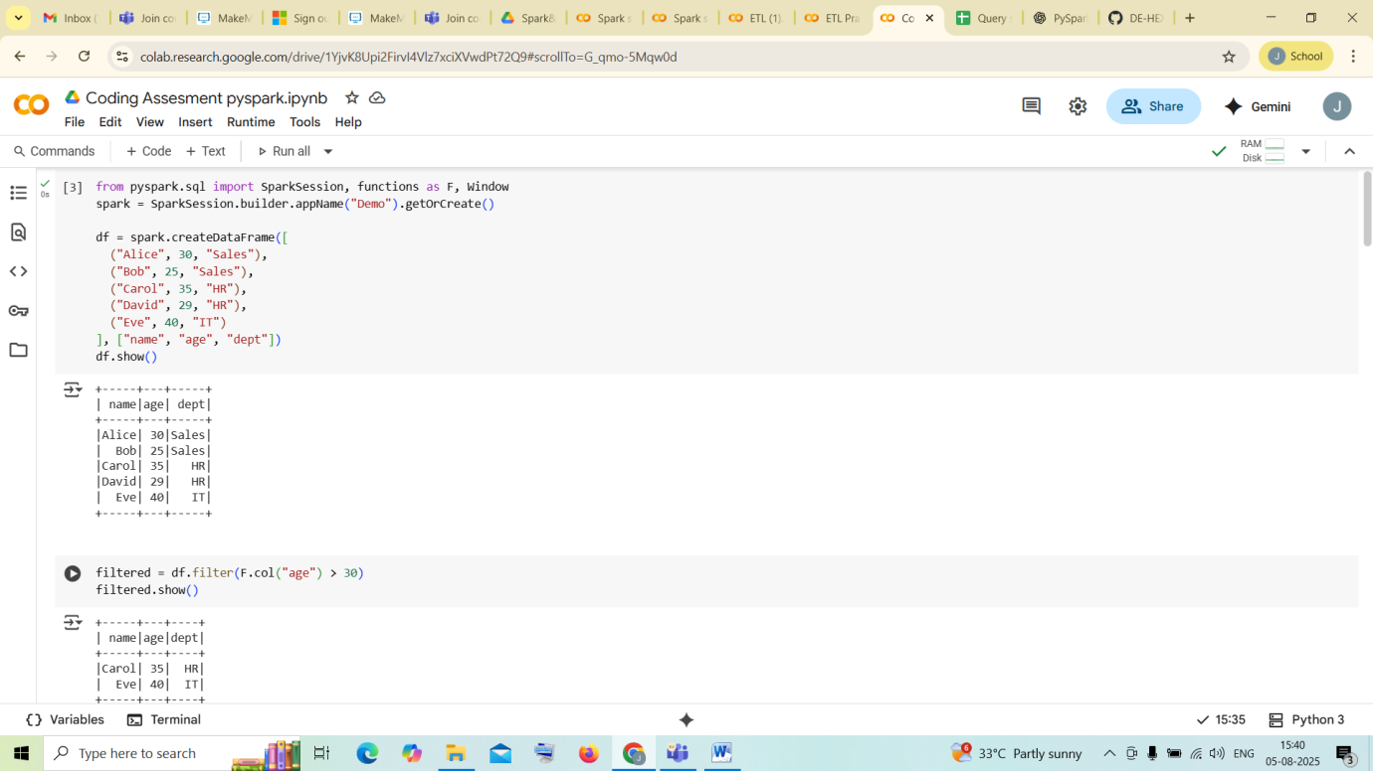

1. using with column and creating another dataframe to join :

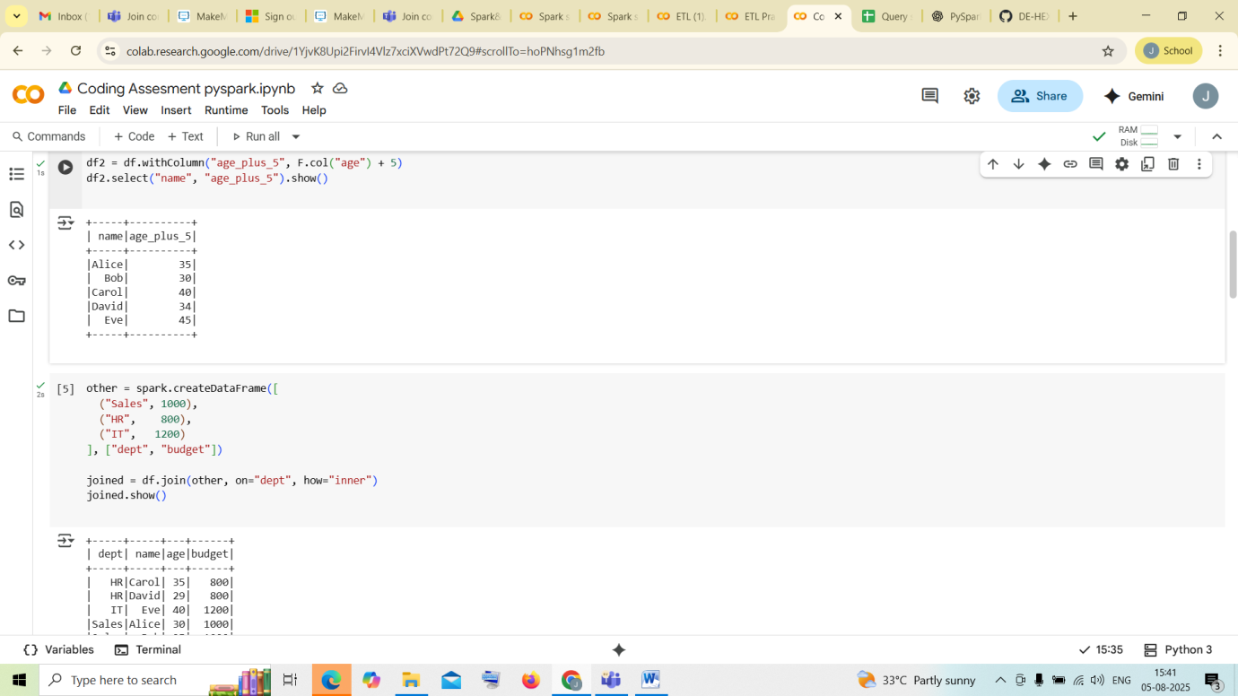

1. Joins and aggregate functions :

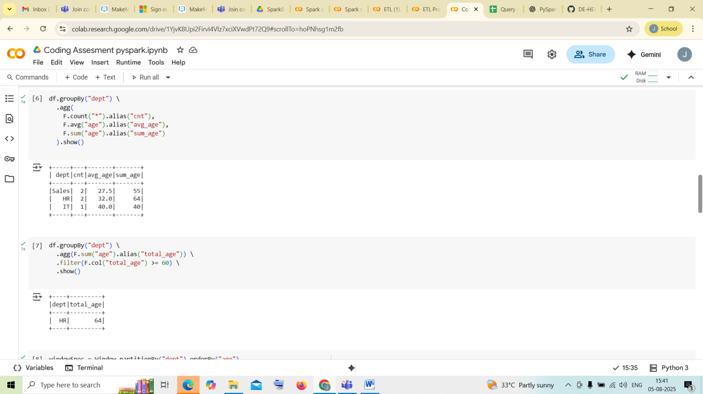

1. Windows

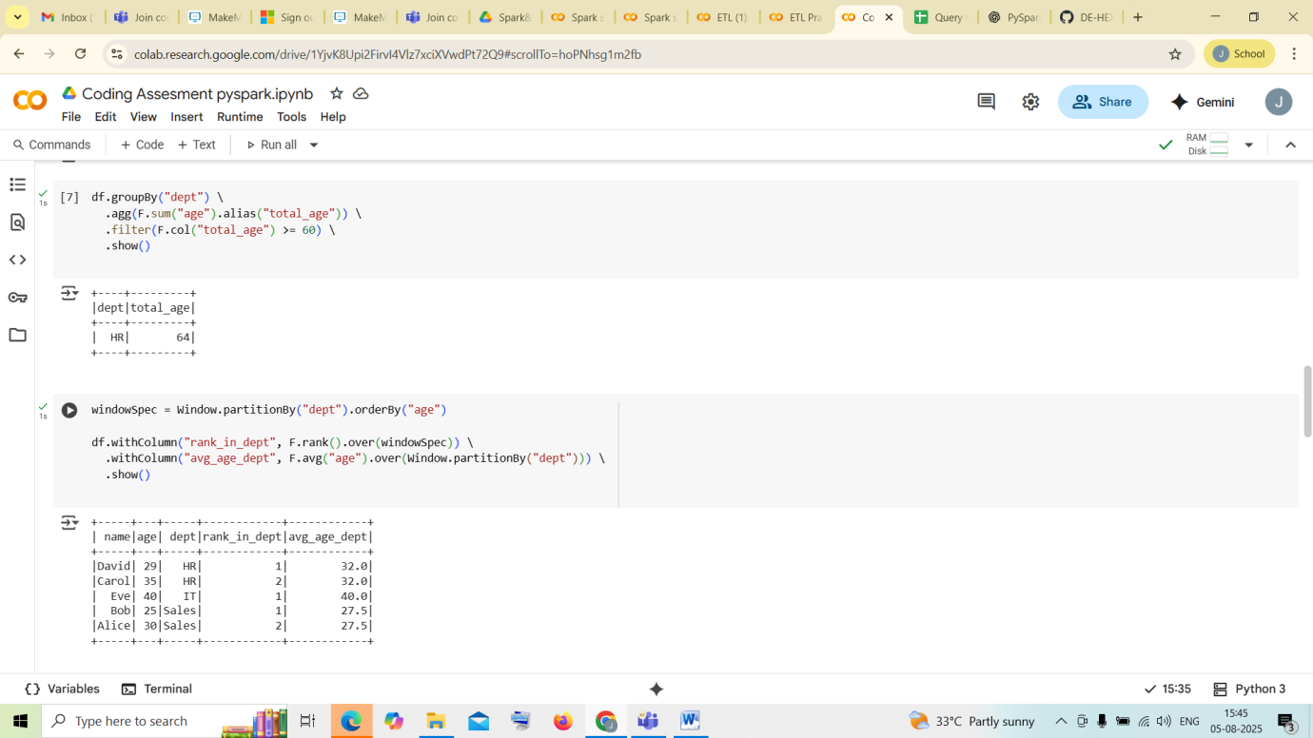

1. Actions :

